Weston Caloyer

Reflection on Visual Rhetoric Project

As soon as this project began, I knew what I wanted my project to look like by the end. I saw the idea of the boxer in the corner, defeated and battered, and I saw the stark white text that stands in contrast to the dark scene. Getting to that point was much harder than I thought it would be. Finding the images became one of the hardest parts. Nothing I could find lined up well, it all looked sloppy and unprofessional. I took a bit of digital creativity (or trickery) on my part to get everything to align in the right way. The very first thing I did was create a background gradient, that would help fill in parts of the boxing ring that weren’t complete, such as the bottom of the image where the text would go. Making it a gradient helped because often times straight black backgrounds do not mix with other images well. 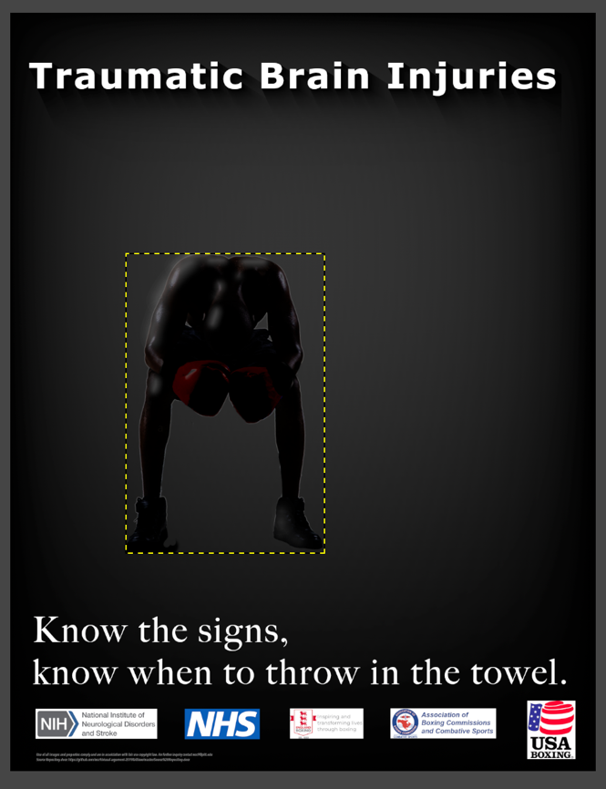I also think it creates a nice vignette around the whole piece. I then set the opacity of each layer to just a little below 100% so that the lighting blended together a little nicer.

Technically speaking, problems started to arise as soon as imported the image of the boxer. He had a bright glowing outline around him, even after using the isolation tool and cutting him from his previous background, so I minimized this glow as much as I could. The second thing I did, was darken the imaged as much as I could. I wanted more of a shadowed figure, rather than a fully identifiable human. So, I darkened the entire layer. This led to another round of problems. The boxer’s shoes were too dark for the floor they were on. So, I took the paint brush and sampled the color of the bright canvas behind him. I used this paintbrush with a very light strength and opacity to touch up the lighting on his shoes, so as to make the light rays behind him look like they are interacting with him. Another thing I tried to fix was the lighting on the rest of his body. One of my comment cards mentioned how hard it was to see the actual posture of the boxer in my piece. He was far too shadowy, and it was hard to see where his head was. So, I did the same thing I did before with the shoes, and I attempted to highlight areas where the light would naturally reflect onto him, making his features a little easier to see.

Another thing I took from the comments, was fixing the misspelling of the word “towel” which I had mistakenly spelled as “towell”, because GiMP does not have built in spell check, and also because I myself have taken one too many blows the head in my sports career. This actually gave me the idea to try and play around with various misspellings in the piece. To make it emulate what happens to the mind after too many TBIs. I thought that it could be quite jarring and impactful, however after some trial and error I decided it did not look good enough to pursue further. The last thing I fixed from the comments, was the title. It used to be “Traumatic Brain Injuries Happen…”, but after talking with Ben, I decided that the statement “Traumatic Brain Injuries” was much more effective, because it makes it seem much more definitive and impactful. I also changed up a lot of the shadowing on the titles, which proved harder to do than I anticipated due to limitations in GiMP. And I also changed the boxer’s gloves from blue to red using the color correction and chroma tool. I did this because I thought red 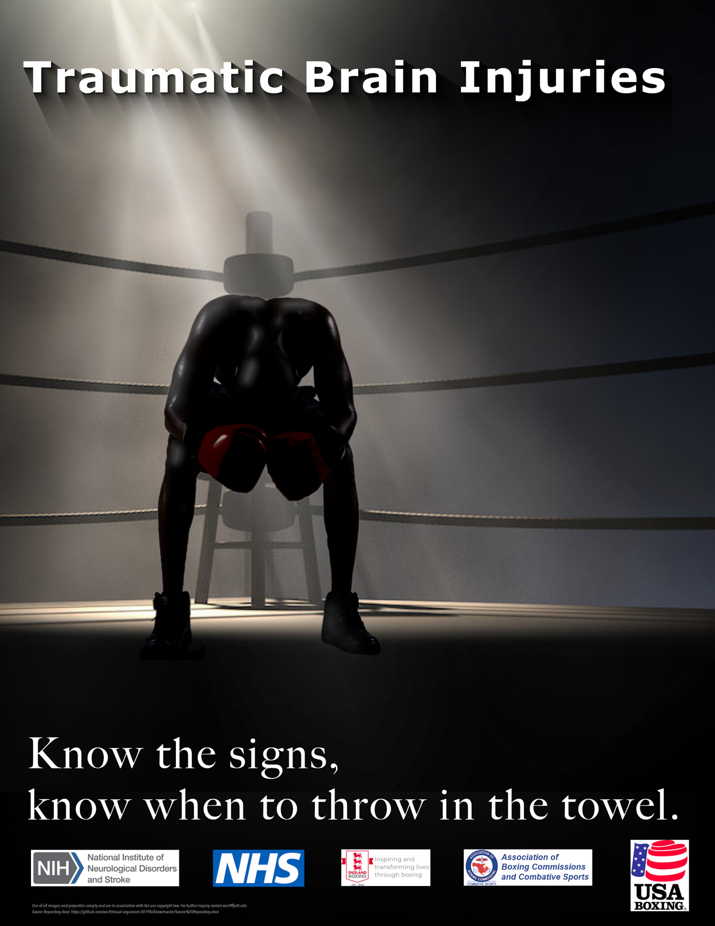looked better, and also is more identifiable as a color of boxing gloves.

